Product Sheet
Product 1028
Style # SKU-L519
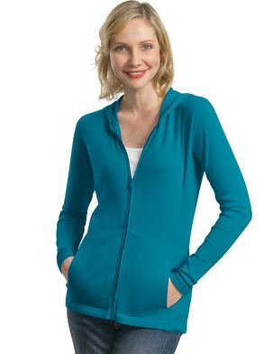
Product Name-Title: Ladies Cotton Stretch Knit Full-Zip Hooded Jacket- Pricing Includes Embroidery
Description: Ladies of all shapes will love this Modern Stretch Cotton Full-Zip Hooded Cardigan. With an updated fit and figure-flattering details, the extra soft cotton is combined with a dash of spandex to retain shape and make the most of yours. We've added extra length throughout the body for styles that move with you for exceptional comfort all day long.
A cozy top layer, our hooded cardigan has extra length in the body and the sleeves for comfort from 9-to-5 and into the weekend. The sleeves can be pushed up or folded up for versatility. Whether you are short or tall, this will be a perfect fit.
- 6.5-ounce, 96/4 cotton/spandex stretch fabric
- 1x1 rib knit construction
- Gently contoured silhouette
- Self-fabric hood
- Dyed-to-match zipper
- Front slash pockets
- Open cuffs and hem
Adult Sizes XS-4XL
See the Size Chart to select the correct fit. Click the Back Arrow on your browser to get back to this page!
Pricing includes embroidery in one location. Click Here to view the Embroidery Options and Embroidery Thread color choices available.
Keywords: Ladies Cotton Stretch Full-Zip Cardigan
Price: Quantity breakdown
1-5 6-35 36-71 72
41.99 35.99 33.99 33.49
43.99 37.49 35.49 34.99
46.49 40.49 38.49 37.99
47.99 41.99 39.99 39.49
Links to Images: Full Size
Small Size:
Thumbnail Size:
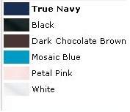
Options:
- Colors: Colors
- Sizes: List all Sizes XS – 4XL

- Link to Spec Sheet or Size Chart
http://www.apparelvideos.com/cs/CatalogBrowser?todo=ss&productId=L519
- Link to Thread Chart
- Link to Design Layout Sheet or to an email link to upload custom design
- Link to Monogram Sheet

Product Distributor – San Mar
Catalog Style #: L519
Price:
XS-XL 2XL 3XL 4XL
15.99 | 16.99 | 18.99 | 19.99

Contact Info:
Your Customer No.

