Product Sheet
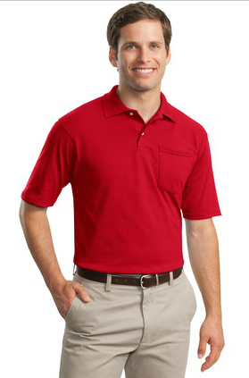

Style # SKU 436MP

Product Name-Title: JERZEES® -SpotShield™ 5.6-Ounce Jersey Knit Sport Shirt with Pocket

- Description: 5.6-ounce, 50/50 cotton/poly preshrunk jersey with SpotShield™ stain resistance
- SpotShield fabric repels water and most oil-based spills
- Tag-free label
- Welt knit collar
- 2-button placket with reinforced bottom box
- Pearlized buttons
- Seamless body with double-needle sleeves and hem
- Oxford is 47/53
- Ash (formerly Birch)
S-3XL
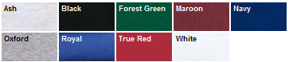
Keywords:

Price: Quantity breakdown
1 2-5 6-35 36-71 72 144 and over
S- XL 46.50 28.95 22.29 20.69 19.89 19.59
2XL 46.99 29.49 22.89 21.29 20.49 19.99
3XL 48.49 30.99 24.29 22.59 21.89 21.59

Links to Images: Full Size
Small Size:
Thumbnail Size:
Options:
- Colors: List all Colors
- Sizes: List all Sizes
- Link to Spec Sheet or Size Chart
- http://www.apparelvideos.com/cs/CatalogBrowser?todo=ss&productId=436MP
- Link to Thread Chart
- Link to Design Layout Sheet or to an email link to upload custom design
Product Distributor – San Mar

Catalog Style #:436MP
Price:
S-XL 7.40
2XL 7.78
3XL 8.78
Contact Info:
Your Customer No.

